**INDIAN INSTITUTE OF TECHNOLOGY, MADRAS**

**BS IN DATA SCIENCE AND APPLICATIONS**

**BUSINESS DATA MANAGEMENT**

**MID TERM SUBMISSION**

**SALES, BILLS AND INVENTORY MANAGEMENT**

**ANALYSIS OF LOUIS PHILLIPE**

**SUBMITTED BY-**

**KUNAL GUPTA**

**21f3001818@ds.study.iitm.ac.in**

**EXECUTIVE SUMMARY**

This BDM Capstone Project is on the topic of interdisciplinary SKU sales, Inventory analysis, Customer retention rate, average sales of Louis Phillipe, A garments outlet in Faridabad, Haryana.

The outlet sells daily products like Blazers, Shirts, T-shirts, Trousers, Pants, Jeans, Ties, Belt, Socks etc. to Luxury items like One-Piece suits and Three-Piece suits, Limited Edition Ties and Belt.

The SKUs belonged to these groups. The data was provided for the fiscal year 2022 from April to October. During the interaction with the owner, he revealed that he was not able to manage the data of most performing SKU and least performing SKU. Further, he wanted to know his average sales per month so that he can plan more extensively to get the best results.

I analysed the data given using excel and its functions like pivot tables, VLOOKUP’s, etc. Created graphical representations, volume, and revenue Pareto’s and did further analysis. This mid-term submission document has detailed analysis methods, proof of the originality of the data, and pictorial representations of some of my analytics.

**PROOF OF ORIGINALITY OF THE DATA**

The data collected by me is primary data, which means that data has been collected personally through one-to-one interaction with the shop owner. The given data was cleaned in excel before analysis.

A Survey link was not required in this situation and hence not used.

To Whomsoever It May Concern

This is to certify that I Navneet Kumar Gupta, owner of Vandinye Exim Pvt Ltd having a Louis Phillipe Store in Faridabad, Crowne Plaza Mall is giving a data for the fiscal year 2022 from April 2022 to October 2022 in excel format but not analysed.

I approve that Kunal (21f3001818) a student of BS degree Program, IIT Madras reached out to me for his Capstone Project in Business Data Management Course. We interacted and I told him about some problems which I am Facing nowadays in my business. I hope that the data which I have provided him will help him to analyse it, find the results and successfully complete his project. Also, help me with these business problems.

As per our conversation, I hope that this data provided must not be shared with anyone and should be used for academic purposes only.

I wish him luck for his future endeavours.



Navneet Kumar Gupta

(Owner of Vandinye Exim Pvt Ltd)

I, Kunal student of IIT Madras, confirm that I will not share this data with anyone else and whatever is shared with me will be used purely for academic purposes.



Kunal

(Student)

Pictures showing the owner, myself with the owner, and the owner dealing with the customers, inventory, and general items of the shop.

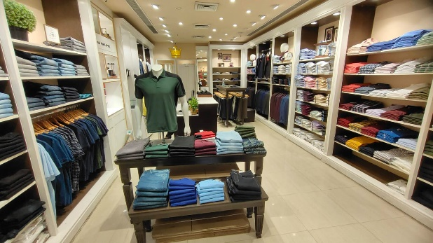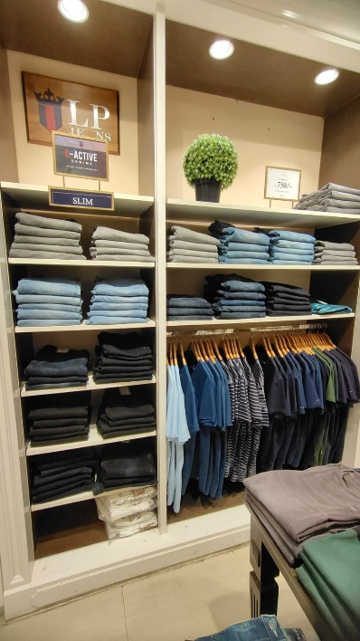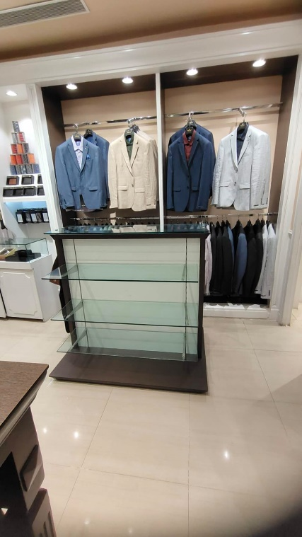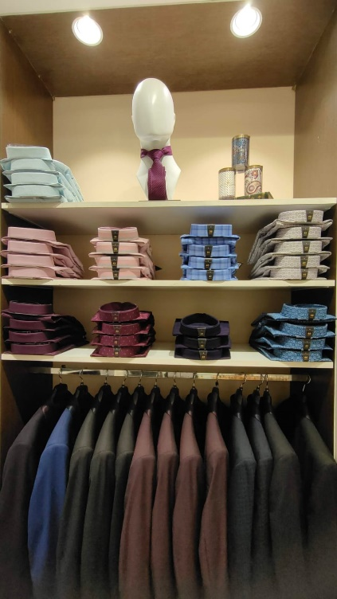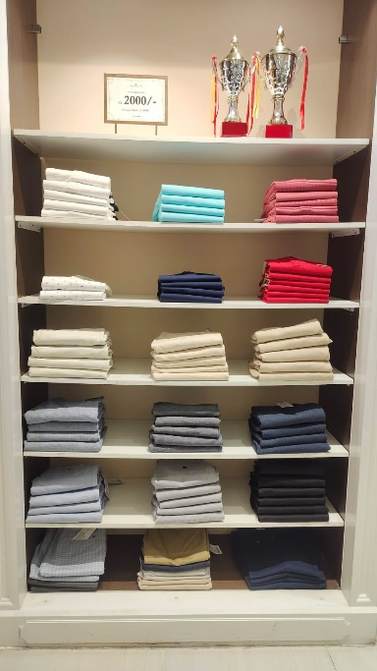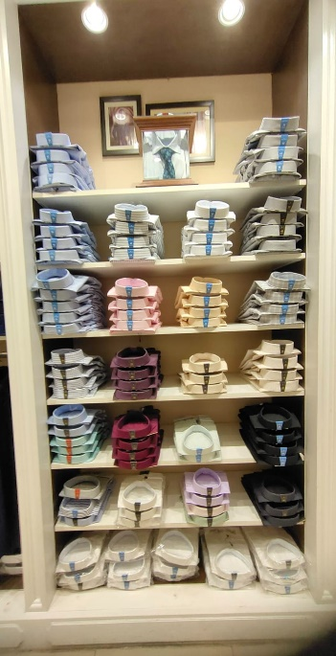

Short videos of the interaction with the business person (uploaded in the google drive).

LINK- <https://drive.google.com/file/d/1HYx-bki20L-cbBRcAQhrD7RpFVMwfPP1/view?usp=share_link>

Video contents –

1. The video deals with the general introduction about the shop owner, his establishment.

2. The video explains what are the ranges of problems faced by the owner an informal discussion

3. This video tells what are inventory update days which means the ongoing trending clothes and future trend analysis.

4. The solutions to the problems expected - best and worst SKUs, average sales per month, and general inventory analysis.

**METDATA AND DESCRIPTIVE STATISTICS**

2 excel documents - first one is the data obtained from the shop and second consists of the analysis which I am doing presently. The descriptive statistics have been included in the main excel itself.

➢ **Master Data** – The "Master Data" sheet serves as the central component of our dataset, containing essential information about various business units (BUs) and their associated products. The dataset is organized into five distinct business units: Shirt, Pants, Blazer, Suits, and Accessories. Each business unit is characterized by specific stock keeping units (SKUs), which are unique identifiers assigned to individual items within each BU.

* **Business Units (BU):**
  + Shirt
  + Pants
  + Blazer
  + Suits
  + Accessories

**➢ Stock** **Purchased**– This is the second sheet of the dataset. The first column is invoice number. The 2nd column is the date on which the store got the stock, since Louis Phillipe is a Franchise, hence the stock comes in large, small amounts depending on need. The 3rd column is stock units, 4th column is total amount paid of stock on that day and 5th column is total percentage of GST to be paid.

➢ **Sales Data** – This is third and very pivotal sheet of the dataset. The 1st column is date, from 1st April 2022 to 22th October 2022. The 2nd column is for Total Bills, which Total bill made on that day. The 3rd column is Volume, the volume of SKU sold of that particular SKU on that particular day. 4th column named as total amount tells us about total revenue of that day. 5th column named as total bills2 gives us the information about number of billed cancelled or if product is refunded. 6th column tells us about the quantity which were returned back. 7th column named as total amount4 tells us total amount deducted of returned goods. 8th column named as total bills5 gives us the amount of total bills made on that day after subtracting it from column 5 i.e., total bills2. 9th column named as total qty gives us the final number of goods sold on that day after subtracting it from column 6 i.e., qty3. 10th column named as amount tells us about final sale of that day. This is calculated as 4th column – 7th column. 11th column gives us the information about transaction done in cash. 12th column tells us about transaction done in credit card. 12th column tells us about transaction done by other modes like UPI, Paytm etc.

**• Dataset-Louis Phillipe Outlet- Analysis**

This dataset has several sheets, right now it has 13 sheets. It has detailed analysis on the

dataset which we have obtained from the shop.

I have created several sheets –

**1. Master Data**

**2. Sales Data**

**3. Ledger** – sales that happened on that day, total bills made total number of SKU sold each day, number of bills which were cancelled, amount refunded, final numbers of bills made final amount of sale that day, sales divided in cash, credit card and others (UPI etc).

**5. Help_for_Ledger** – It is pivot table created from Sales data, with months as rows. And different parameters in column according to our need.

**6. Volume Pareto** – The SKU and the volume sales, and pictorial representation for the

volume sales.

**7. Revenue Pareto** – The SKU and revenue obtained, and pictorial representation for the

revenue.

**8. Scatterplot** – Scatterplot for revenue vs sales.

**9. Volume Trend** – The trendline for volume sales.

**10. Revenue Trend** – The trendline for revenue of the sales.

**11. Day-wise Trend** – The trendline for every month and the week wise trends for sales and

revenue.

**12. Days of Sales Available** – This is a dynamic sheet. If we select the SKU from cell B1,

then the opening stock, average sales, and days of sales available across 3 months for that

particular selected SKU.

**13. Days of inventory** – For each SKU, we have calculated the average open stock, average

sales using AVERAGEIF function and then finally calculated the average days of

inventory.

**DETAILED EXPLANATION OF ANALYSIS PROCESS/METHOD**

1. **ANALYSIS OF SALES AND INVENTORY**

We have used the master data and the sales data and inventory for this purpose. First of all, the sales data has been modified, against date. Then we have the volume of SKU sold on that day,

Total sales of that day, to get the revenue. Now using this data,

we create a pivot table from inventory data. Here, in sheet1 we put the rows in sum of value table named as sum of units and sum of total quantity sold and bar graph is made to show

relation total units in stock purchased that month and total unit sold to the customers.

Second sheet consist of relation between total bills made in particular month and final bills including returns and calculated bills.

Third sheet tells the relations between Revenue and total sales with respect to months.

Fourth sheet tells us the total numbers of bill made each month represented in scatter plot.

Fifth sheet tells us about total payments made by credit card in form of pie chart for each month.

Sixth sheet gives us the information about total sales for each month.

Another sheet gives us the information about sum of units vs total quantity sold, means total stock purchased that month vs total quantity sold.

**Closing Stock = Opening Stock – Sales + Inward Stock**

This helped us to get the sales and inventory for the volume of all SKUs. Next day inward stock will be stock left on previous day.

1. **BEST AND WORST PERFORMING MONTH AND DAYS**

For analysing the best and the worst performing Month and days, we need to consider two aspects –

Volume wise and Revenue wise. Again, from our edited sales data sheet, we create a pivot

table. First of all, we will look into the volume aspect. We make Units and sales as the rows and the values taken are the sales of volume (cumulative). We need to see total count of SKU was sold for each day. Pivot tables in excel do not allow any kind of sort functions.

We also created a graph depicting the volume pareto with SKUs on x-axis and volume sales on y-axis. In the same way, revenue pareto was created with rows of SKUs and sum of revenue as the values.

For best month we calculated total sales for each and every month and the month with highest sales will be termed as best performing month and month with lowest sales will be termed as worst performing month.

In days format we check total sale of each day and day with maximum sale for that month will be considered as best performing day of that month.

If we look into worst performing days, days with minimum sale including 0 sales will be considered as worst performing days of that particular month.

**3. AVERAGE SALES PER MONTH**

From our edited sales data sheet, where we had calculated the revenue for each day Unit wise. We created a pivot table, with months as the rows and sum of revenue as the values,

we obtained the revenue for each month. The average sales per month in terms of revenue obtained 3,35,969 rupees. In another pivot table created from the sales

data, we put months as the rows and sum of volumes as the values. We get the sales for each month. The charts describing the revenue and volume sales are also created for better understanding.

**RESULTS AND FINDINGS**

**1. ANALYSIS OF SALES AND INVENTORY**

We found that the when the store had good stock management sales with rising. On the other hand, if stock was not managed for that month sales were not upto the mark.

Here first graph tells us about total units purchased vs and total unit sold in that month and second graph tells us about total sales in that month based on units sold.

**2. BEST AND WORST PERFORMING MONTH**

We found that Aprill was best performing month and September as worst performing month of both revenue as well as volume sales, we are not considering October here as we got data till mid-October only and in consideration of previous trends October was not worst performing.

Here first graph shows us total bill made each month which indirectly tells us the trait of sales which can be confirmed in second graph that April was best performing month and September was worst performing month.

1. **AVERAGE SALES PER MONTH**

|  |  |
| --- | --- |
| **Row Labels** | **Sum of Amount** |
| Apr | 622419 |
| May | 400598 |
| Jun | 308149 |
| Jul | 356531 |
| Aug | 270470 |
| Sep | 205571 |
| Oct | 188047 |
| **Grand Total** | **2351785** |
|  |  |
|  |  |

The graph and table shows total sales.

|  |  |  |
| --- | --- | --- |
| **Row Labels** | **Sum of Total Amount** | **Sum of Amount** |
| Apr | 615130 | 622419 |
| May | 448480 | 400598 |
| Jun | 335140 | 308149 |
| Jul | 403664 | 356531 |
| Aug | 311402 | 270470 |
| Sep | 235527 | 205571 |
| Oct | 197694 | 188047 |
| **Grand Total** | **2547037** | **2351785** |
|  |  |  |
|  |  |  |

Here the table and the graph shows total sales vs total revenue generated by the store.